Spotify is an excellent streaming music service that makes you can enjoy lots of streaming content. It has tons of great music, exclusive tunes, and podcasts, all of which combine to make it a top pick for streaming music and more pop culture-related content. Spotify, available in both free and premium versions.

Thus, some services are only open to premium users like listening to Spotify music in offline mode. However, these downloaded music files are encrypted which are not viewable on other devices without Spotify. Meanwhile, you will not be able to keep those music files once you stop the subscription of the premium plan on Spotify.

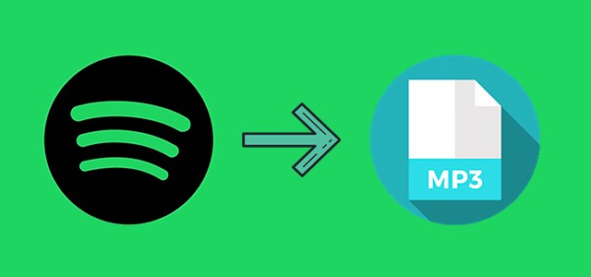

Therefore, the best method is to convert Spotify music to plain audio formats like MP3 so you can hold Spotify music tracks forever and listen to them without the limitation. When it comes to converting Spotify music to plain formats like MP3, there are plenty of Spotify music converters on the market. We do recommend Tunelf Spotify Music Downloader.

Tunelf Spotify Music Converter is an excellent music converter for both premium and free Spotify users which can download music from Spotify and convert Spotify music to MP3 and other audio formats. With its help, you can stream Spotify music to any devices like wearables, game consoles, smart speakers, and more even without an Internet connection.

What You Can Get from Tunelf Spotify Music Converter?
Download Spotify music for listening anywhere without premium account
Convert Spotify songs to several popular audio formats like MP3 and AAC
Support the offline playback of Spotify on any devices without limitation
Preserve Spotify music tracks with the lossless audio quality and ID3 tags

Here are the complete steps to download music from Spotify to MP3:

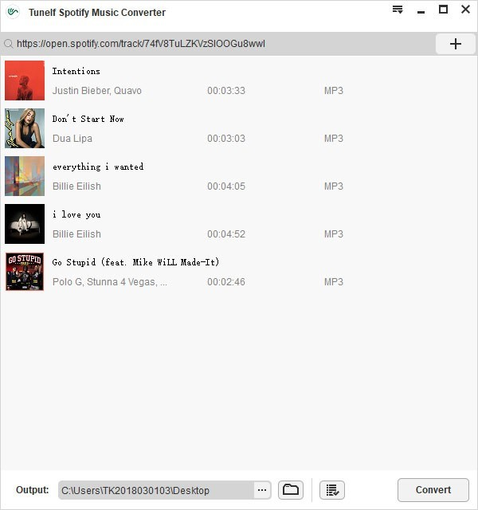

Step 1: Launch Tunelf software on your computer and then wait for the automatic opening of Spotify. Log into your Spotify account and navigate to your library on Spotify. Find your preferred Spotify tracks and drag and drop them to the main home of Tunelf.

Step 2: Go to [Menu] > [Preference] > [Convert] and then begin to select the output audio format including MP3, AAC, FLAC, WAV, M4A, and M4B. Besides, adjust the bit rate, sample rate, and channel for getting better audio quality.

Step 3: Click on the [Convert] button to begin to download music from Spotify and Tunelf will save Spotify music tracks to the folder you specified. After the conversion, you can go to browse the converted Spotify music tracks in the converted list.

