**Firstly, The Team Members:**

The team that is working on this problem is consisting of only Mai Elsayed Mohamed Mostafa only. Mai is a teacher assistant in faculty of Mass Communication, Advertising and PR at October University of Modern Science and Arts (MSA). Additionally, she is a student in both supplementary bachelors and master’s program in political science at Cairo University. She also took a minor in management science. Mai took part in different student activities and reached high positions. Such as, the president of the training department at MSA University and a team leader in an NGO in Egypt.

**Secondly, the Problem Statement:**

Cairo,

ShandawilVillage

**Problem Statement 1:**

The chosen project and problem statement is Shandaweel Women’s issue. These women are known for their crafting skills; mainly in the beautiful Al-Tally fabric. However, these women are having difficulty in reaching a proper market, attracting customers and show case their products, and achieving financial sustainability. Based on investigations it was shown that these women are having different challenges related to their tally crafting. This is due to the lack of financial resource, lack of knowledge, and lack of cooperation as the sense of competition is controlling. This made them have a difficulty in selling the products they spent money and huge efforts on. Additionally, their geographical location and culture has an effect on them reaching a proper market, target audience, and gain profits.

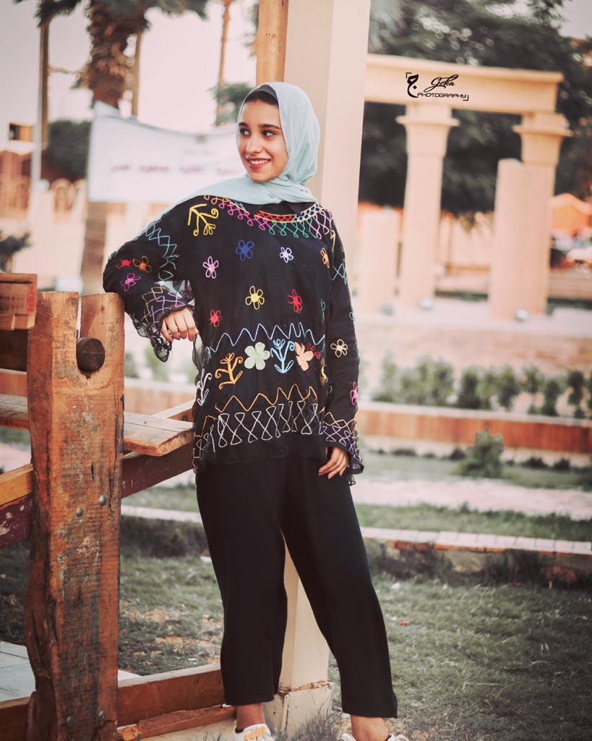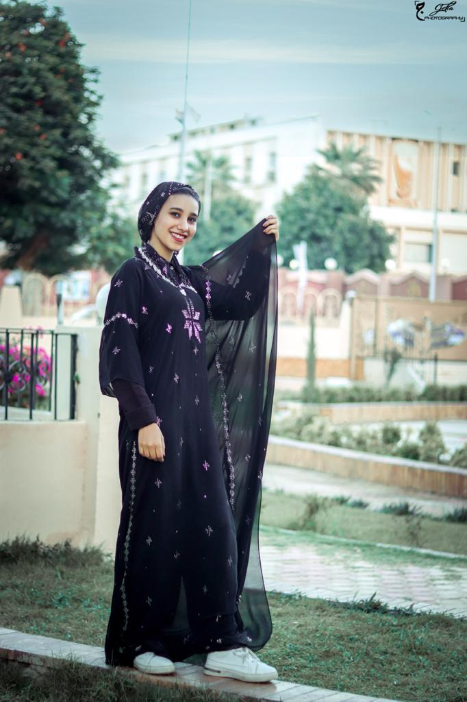

* This paper will include the steps that were taken in order to reach the solution, the detailed challenges, and the four-step solution model in detail. This will act as a stable template to be used easily. It was important to find the easiest, most effective and efficient, and timely solution. This is the result.

**Thirdly, in order to reach an effective and efficient solution, steps should be created.**

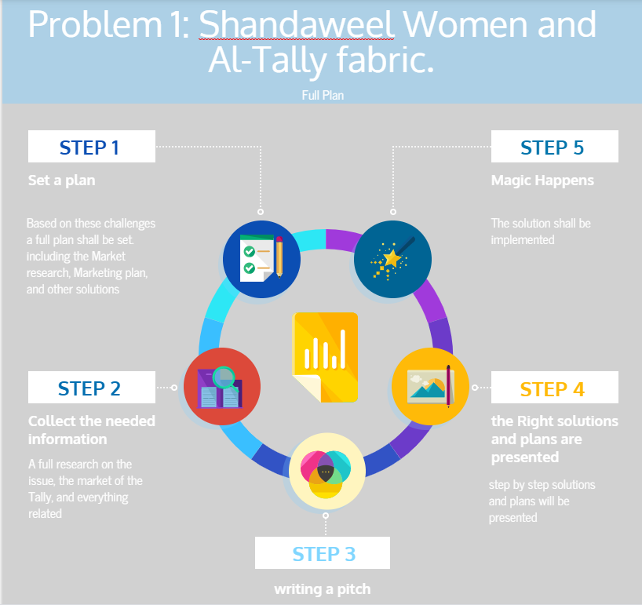

**Step 1,** is to set a full plan on how the project shall take place. This plan will be seen throughout the outline. This plan included the problem, the challenges, and the solutions.

**Step 2,** is to collect the needed information to understand the issue, understand the people there, and create the most fit with the lowest cost solutions. Also, to find the solutions that could be easily done.

**Step 3,** is writing the full model to present it and to have a guide on how to solve the issue.

**Step 4,** after writing the pitch the best solutions are then crafted and are well written in the pitch.

**Step 5,** is where magic happens. The final outcome of the project. Also, this project would be studied well and implemented in real life as a project. Where volunteers would be recruited , training would take place, and implementation of the model alongside Project Nitrous and Giza systems education foundation.

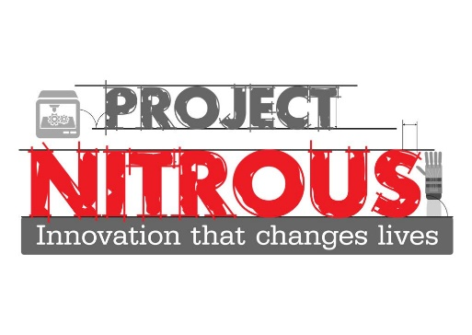

**Fourth, each problem has challenges that could act as obstacles for reaching the desired outcome. Thus, challenges should be considered.**

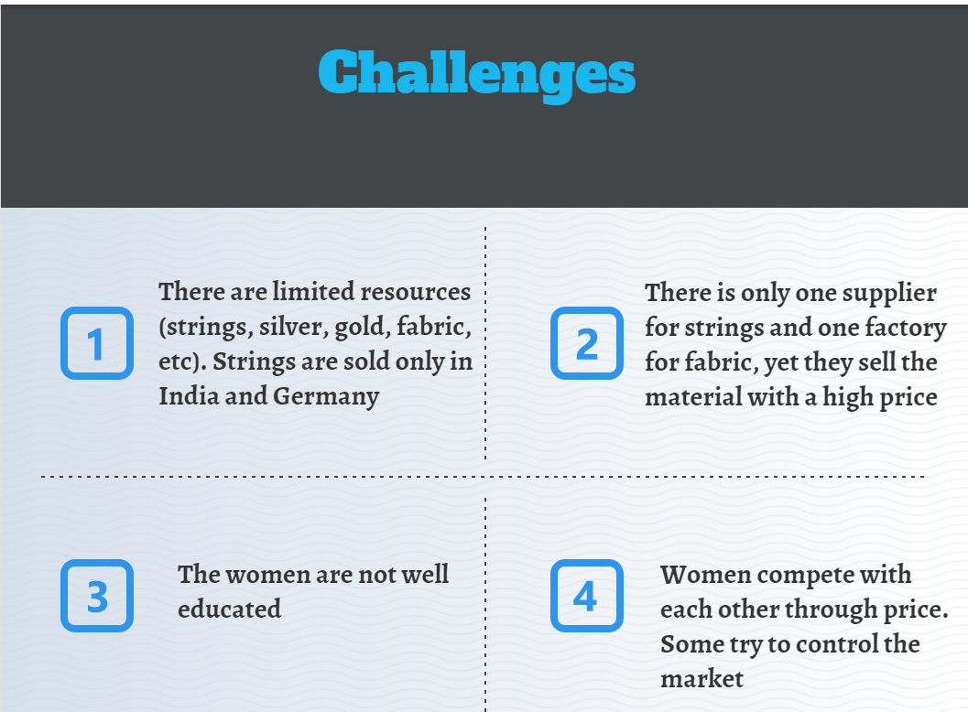

**Firstly**, there are limited resources. such as, strings, fabric, gold, silver, and other resources. the strings are sold in India and Germany. Thus, the prices are high in comparison to their financial resources. This would result in them not being able to buy the essential resources for their Tally crafting.

**Secondly,** there is only one supplier for these strings and one factory for fabric that are monopolising the market. They set a high price for every Kg of strings and meter for fabric. The supplier sells every Kg of strings for 1200 L.E and set the quota for buying minimum 20 Kg. unfortunately, they have little financial resource which is an obstacle for them. Some of these women would take a bank loan, but they are not able to settle it.

**Thirdly,** the women in Shandawil are not educated some of them did not attend schools. Also, some are not well educated about how to sell their products and how to reach the audience and gain profit. Thus, they are not able to market for their products, set a marketing plan, and reach the correct markets. Some would use wrong tools, while others have no knowledge about how to sell their products.

For instance, it can be seen in this post that the owner was not able to take a good picture and write a catchy post.

https://www.facebook.com/100031862045451/posts/383685769370155/?d=n

**Fourth,** due to the lack of money and the limited number of selling. Women started to compete against each other through reducing the price. Some of them who have their relations were able to mobilize the market and hinder the selling process of the other women. ‘women became the enemies of women’. This resulted in either selling the product at a really low price with high cost and effort or causing obstacles for other women to sell their products.

**Fifth, The Solution**

The solution that will be proposed is the Four Step Solution Model.

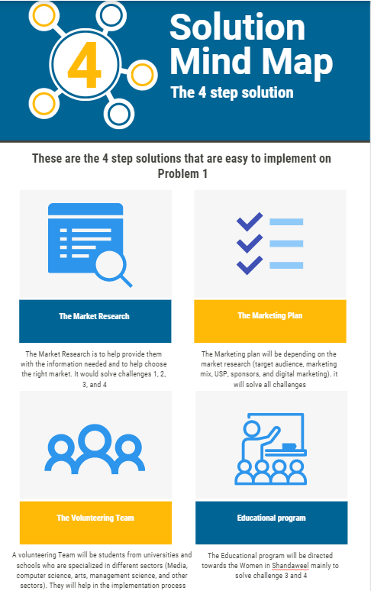

This solution is set to solve all challenges in one program. The aim was to find the best solution with the lowest cost, most effective and efficient, and easiest solution. Also, to find the most fit solution that would solve all challenges. This model could to be done and implemented easily. It is estimated to take from 6 months to 1 year and a half.

**Firstly, the Market Research shall study the market of the tally to help these women understand the markets they are working in. also, it is used as a beginning in order to set a form for usage when implementing it.**

**Market Research Proposed Model**

**Introduction to the product.**

This part acts as an introduction to what the product is. It is important to write an introduction to avoid misunderstandings and enhance their understanding of what they are working on.

**Situational Analysis.**

* **Trend Analysis**

This part studies which time of the year the product is most sold and which the product is least sold. It also studies the future of the trend of selling the product. Whether the product is predicted to be sold the most or least. Whether the trend is expected to increase or decrease, in order to create the changes needed to avoid the decline. Additionally, it studies the previous trends to analyse the future trends. Finally, it also helps analyse the earnings and shares of selling the product during different months that help understand the trend, when is best time to sell the product, and which product is increasing the trend or sale.

* **Internal Information**

this part determines the mission, core values, culture, financial state (budgets and financial needs), resources, resources management, and sales and revenues.

* **External information**

Sales trend of the industry in Egypt, information about the industry, GDP and economy information in Egypt, and any issues regarding the industry, the seller, or the village itself.

* **Consumer Analysis**

This study the most fit target audience and target market. In this part it is important to study any gap in the market that could be filled. In addition to, developing a better understanding of the target audience. Also, they should be determined to understand how to market and advertise to the audience.

* Demographic segmentation
* Psychographics
* VALs segmentation to help understand the people
* Customer persona
* Product usage (Degree of usage, Degree of brand loyalty)
* What motivates consumers to buy (implementing the purchasing cycle which includes the full cycle of purchasing from need recognition to buying decision and the seasonality analysis which sees when is the time that the industry sells the most For examples, the seasonality of the electronics during December and February because electronics are mostly sold in charismas as gifts. The previous information were based on real analysis. Also, where is the best place that the product would be sold the most)
* What do they look for in a product (it tests the special aspects that consumers look for in a product in order to be able to find different unique selling prepositions and an identity for their brand and for the women). These aspects could include their identity as the product could represent them.
* **Market Analysis**
* Geographic area ( the most population of the target audience, best markets to target in the geographic area, and understand the place that has the most consumption of the product).
* Market analysis: analyse the market of the Tally crafting
* **Macro Environment**

Is to gather information about the environment of Egypt

* Political environment in Egypt and how it would affect the product. (restrictions, rules, and trade)
* Economy and how it will affect the product (price, tariffs, and the quality of life of the people)
* Nature (related to the climate and eco-friendly considerations in order to not violate the sustainable development)
* Technology and how to make use of it for the benefit of the product. (one of the best solutions that would be implemented are the digital marketing practices).
* Culture considered creating products that would align with the values of the consumers. Also, focusing on the culture would be a benefit for the tally as it is an Egyptian heritage product. It will also affect the advertising
* **Product Analysis**
* Branding awareness is considered which stage the product is in (unaware, aware, loyal, etc)
* Product attribute include the tangible and intangible aspects of the product
* Product function includes the benefits and the job of the product
* Prising includes the best pricing strategy to solve the challenges and determine the cost and price of the product in the market.
* **Competitive analysis**
* Competitive set includes the four stages of competition (product form which is the identical product. Mainly the competition in the village, product category which is the same industry. the clothing industry, generic which fulfils the same need, and budget are the products that are exactly the same price but different industries).
* **SWOT Analysis**
* Strengths (internal strengths)
* Weakness (internal weakness including the limited budget)
* Opportunities (external benefits)
* Threats (external issues. Such as, economy and the suppliers)

**Secondly, the marketing plan that compliments the research**

* **Objectives**
* Time
* Marketing objectives
* Advertising objectives
* Communication objectives
* Overall goal
* **marketing Mix**

Determine the Product (core, actual, and augmented), place (distribution channels), price (cost, price, and pricing strategy), and promotion (price off deals and the communication channels. Including digital media).

* **Organizations willing to sponsor the product**

This part solves the first two challenges that are the price of the resources and affording the resources needed. This part is related to finding NGOs or organizations that are interested in funding young entrepreneurs. The sponsoring money would be directed towards the strings and the distribution channels for them. They could be appealed to through effective images of the products and social media advertisements that would be done by the Volunteers. It is a short-term solution

* **Creative Message**

This is the stage where the message should be crafted to create a brand identity. It does not only depend on the logo or the slogan only, but several factors. Consistent and logical message, employing the best advertising strategies based on the budget and the target audience, depend on the verbal and visual elements, provide the best execution styles and appeals, creativity, include the unique selling product that would make a brand competitive, have big unifying idea, and include the promise of the brand.

Also, include the message type informal and transformational or creative.

* **Strategic Focus Point**

Is where the women would each identify a specific unique aspect of their products. One could be in regards of the price, the other would be in regards of the quality, and other would be in the design. Thus, it would reduce the competition between each one of them. Also, this will help in generating sales and in entering the market.

* **Positioning Statement**

Choosing one of the 7 statements to provide as a promise and the core of the ads

* + **Attributes/Benefits** – setting the brand apart from competition using specific characteristics or benefits offered. Marketers attempt to identify *salient benefits* which are those that are important to customers in their purchase decisions
  + **Price/Quality** – using price as characteristic of the brand. High quality/image pricing can be used as well as value pricing which reflects a very competitive price.
  + **Use/Application** – associate the brand with a specific use. This approach can also be effective way to expand usage of a product.
  + **Product Class** – competition can come from outside the product class whereby a product is positioned against another product category
  + **Product User** – associating a brand with a type of person or group that uses a product or service.
  + **Competitor** – positioning a company or brand against a competitor. Often another form of positioning is used as well to differentiate the brand.
  + **Cultural Symbols** – use symbols that have acquired cultural meaning and associating a brand with these symbols to differentiate it from competitors (e.g. Marlboro and the cowboy)
* **Creative Strategy**
* Logo
* Slogan
* Storyboard
* Ads
* Flyers
* Alternative Media
* Social Media or digital media (Facebook, Instagram, and other social media advertisements) and E- Marketing which helps sell the products online and facilitate the selling process. Both E-Media and Digital Marketing are types of advertising that would help in advertising for the products at a really low cost.
* **Big Unifying Idea**

Is the dominant idea of the message and the consistency in the advertisements

* **Advertising Appeal**

Is to choose a certain appeal that most fits the target audience

* **Execution styles**

To choose the execution styles that appeals to the audience

* **Communication Assessment Measures**

These should be done to test during and after the program

- Pre-production Testing

- Postproduction Testing

**Thirdly, The volunteering Step**

This part will depend heavily on recruiting volunteers from different sectors (Media, Arts, Engineering, Computer science, and other sectors). This part is easy to implement in which in Egypt people are now interested in Volunteering and want to take part in any volunteering activity especially in the sustainable development goals. Also, because the youth in Egypt search for any opportunity to volunteer, gain a certificate, and fill their CVs. These volunteers will take the proper training in Marketing, communication, persuasion, body language, education, SDGs, and especially women empowerment.

**Fourth, the educational program**

The educational program is directed towards the women in Shandawil. It includes different sections. Firstly, the community section, where both the members of the organization and the volunteer would work directly with these women to create a collective community. this will help achieve a community building. This will happen through trainings and educate them about the good outcome of a collective community.

Bearing in mind the following information:

* **Audience Analysis**

The target audience of the educational program: Shandaweel’s women. There are several categories their geographic, demographic, psychographic and behavioral. It’s very important to know the location of the target audience, where they live, their gender, nationality, age, social class, life style, loyalty and attitude towards the program. the main goal of these analysis is to know more information and more details about these women and to know how they will react towards the program. Also, be able to understand them to find a common ground and to formulate the best strategies in this program.

* It is also important to consider and understand the needs, emotions, and attitudes of the audience.
* **Determining the needs:**

This point helps understand their needs in order to use it to help them know that the aim is to help them and to help fulfil their needs. For example, this segment has the need for money, some of them have the need for food and shelter, and others have the need for education.

* **Forms of organization:**

Is how the message shall be sent. the message that is needed to be sent to the target audience is that they should be collective, help each other in order to reach the market, they have to work together in order to reach the consumers and solve their issue, and help their community be well known for their beautiful tally fabric crafting.

There are several forms of organization to be used: The first one is called Organization by Topic which is considered the most advantageous and helpful form in which the message delivered to the audience contains various topics or problems. Moreover, it means stating all the benefits and points the audience will get after buying the product or idea. The second one is Organization by Space, it is a great preference when it comes to the comparison of your topic to another bigger image. Furthermore, it means delivering the message to the audience based on comparison, for instance comparing my own experience and achievements with the other. The third one is called Organization by Chronology, where the audience are taken through the problem in a historical and chronological order and dates that can include narration in it. In this form, dates don’t lie as well, so people believe the idea. The forth one is called Organization by Stock issues, it consists of the need for change, plan to solve the need, and the plan that meets the need. This will bring fear to the audience as they will feel that they will set a need for change. The last one is Organization by the Motivational Sequence and it consists of four main steps. The first one is the attention step in which the persuader use a quote, question, or fear in the beginning. The second one is the need step which means creating a need or desire to the audience by persuading them that they are near to lose something making them scared about their position. The third one is visualization and satisfaction step, which is bringing a testimony or a group leader that will convince the audience to follow the idea. The last one is realistic action in which you’ll make the audience feel that they are involved in the performance, thus they need to take a step.

* **Forms of Proofs**

One of the most fit forms of proofs for the persuasion narratives and anecdotes which means giving them real life examples that they can easily remember it. Also, testimony which is to bring them someone who is trustworthy and credible to convince them with the idea of being collective. This form is applicable as their group leader will talk to them and prove to them that they are considering a bad choice.

* **Wording the message:**

The wording in the message is the way the message is going to be delivered. In other words, the language that is going to be used. First of all, the language that is going to be used will be slang language as the target audience are familiar with this type of language and they understand it the most. Excluding any formal language or jargon. The words that will be used are simple words. Also, concise language is the most preferable. It is to use straightforward words and statements.

* **Delivering the message**

**The Channel:**

This will help the message be easily delivered to the target audience. First of all, the target audience live in rural areas.

**The Persuader**

The persuader will be trained team and volunteers

**Tactics**

**The Yes-Yes Technique**

This is an effective tactic of persuasion where the persuader use it by asking the audience several questions that nobody answers with no. Hence, they are only programmed in their minds with yes to the idea.

**Don’t ask If; But Which**

It’s always effective to give the audience only two options rather than give them many options because we won’t be able to persuade them.

**Body Language**

there are important tactics to consider in order to persuade the target audience who are the women. The non-verbal communication. It helps provide an understanding of the message by 80%. Within the non-verbal communication there are three aspects in the non-verbal channels.

As the facial expressions and the eye contacts are very important to consider. Firstly, the facial expression as it determines the situation or the message the persuader wants to deliver. It includes many expressions but the expressions that should practice are interest as to show that those people are important, determination, sadness when explaining the problem, they are having and what is causing the major problem, and happiness when implementing what is said.

The eye contacts have five functions. Firstly, attention function as it is known as the mutual gazing. To capture the listener’s attention. During the workshop. Secondly, regulatory function it indicates when a conversation will begin and when it stops. This will happen during the first meeting with the audience one by one. This will have to indicate when the conversation starts and the conversation stops in an organized way. Thirdly, is the power function. This acts as to let people follow what is said. Affective function is to show emotions during the workshop. this function help deliver the message, show emotions, and to show how serious the issue is. Finally, persuasion functions include that eye contact is an effective function in building trust and credibility. Finally, eye contacts to all the audience without neglecting anyone is important.

Bodily communication includes several movements. It shows how the persuader would interact with the people. Firstly, the kinesics, or physical movements of the persuader. The movements will be relaxed but have erect postures and words, and not too relaxed. Also, gestures while talking has three types emblems that is using the figures only, but avoiding the pointing. This type is needed in some words. Then medium gestures those too would be used by the speaker while talking in some situation. The large gestures will be used in some situations sometimes it could be used to indicate how large an issue is.

The head movements will include nodding but not a lot, shaking the head to show disapproval of something, and tilting to show that the team is listening to the person who is speaking. Bodily movements are important as it shows what the persuader is thinking or saying. The persuader should avoid standing in open stance with legs apart, clenching fists, putting hand on the hips, and intense movements. But should move 2-3 steps while talking during the changing of ideas, open the hands and gesture properly, stand with legs not too opened and not too closed, face the audience and never give them our back, should not make the chin up in order to not show arrogance and should not touch people.

It is important to avoid crossing legs or arms, avoid putting a hand the shoulder, and avoid holding both hands together as it is a sign of nervousness.

As for the proxemics, it is essential that the persuader uses a physical space between them and the audience. It includes the public distance in which should will leave from 15 to 25 feet from the audience when speaking to all of them so there should be a distance given. Thus, this one is applicable in order to assure that the message is conveyed to all the audience. The second one is the social or formal distance which most occurs in meetings or job interviews. when discussing a social issue related to the audience, so leaving a distance from 7 to 12 feet between the speaker and the audience during the first meeting with them.

Physical appearance is a primary tool of persuasion the team should be well groomed and should dress humbly as to show common ground between them and the people. No exaggerating in their clothes or jewelry. Thus, the physical appearance is important to deliver the message and it should be in harmony with the idea that is education as the aim is to educate them to make them change their perceptions and attitudes towards the idea of competition.

As for the artifacts, we will choose the clothing as an artifact. Where a women would show her handmade clothes that she sold because of cooperation and it looks good with a high quality in order to encourage the other women.

The vocal features add meaning and energy to the message aimed to deliver to the audience as a result from the sound or voice of the persuader. The speaker should avoid the sounds of hesitation and heavy breathing when saying the message in order not to affect the audience’s response to the message as they can misunderstand it. Also, avoid monotonic because if the speaker is a boring, then they won’t be able to persuade the audience. some words should be said with high pitch voice to show excitement Furthermore, addressing the issue in a low pitch tone to show his issue has negative consequences. Talking in high and low pitch voices to avoid being monotonic.

**The second** educational program is to teach the audience marketing strategies in an easy way in order to create a unique selling point. Each woman will have a unique selling point to sell better. Some will have high quality, some will have design, some in price, and other USP. This will help solve the 4th challenge which is the competition. Also, teaching them will help them keep their product for a long term and to help their product reach maturity and avoid decline. Also, to let them sell their products effectively on their own.

Both sectors of the educational program shall be done in a parallel way.